TO CONNECT ONE MACHINE TO ANOTHER
RESOURCE GROUP
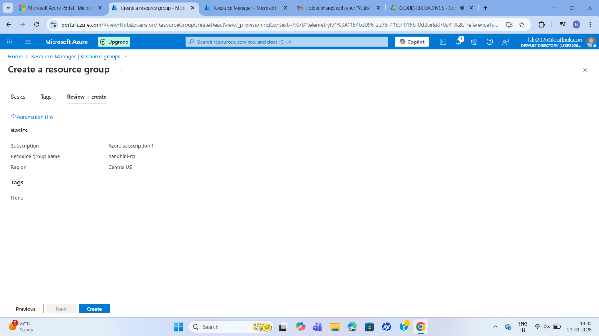
VIRTUAL NETWORK
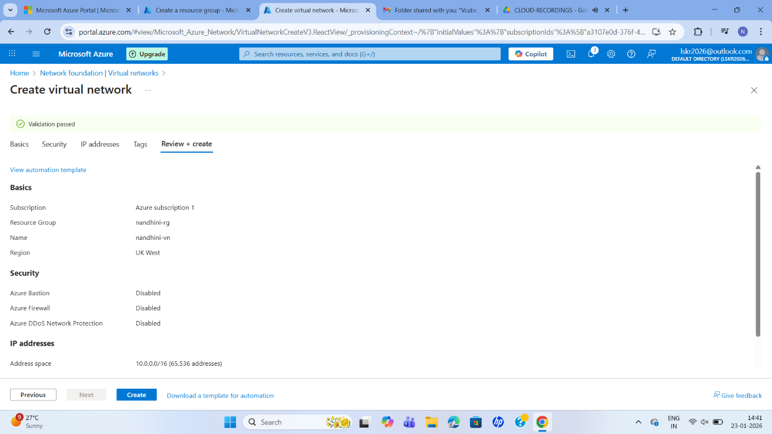
VIRTUAL MACHINE
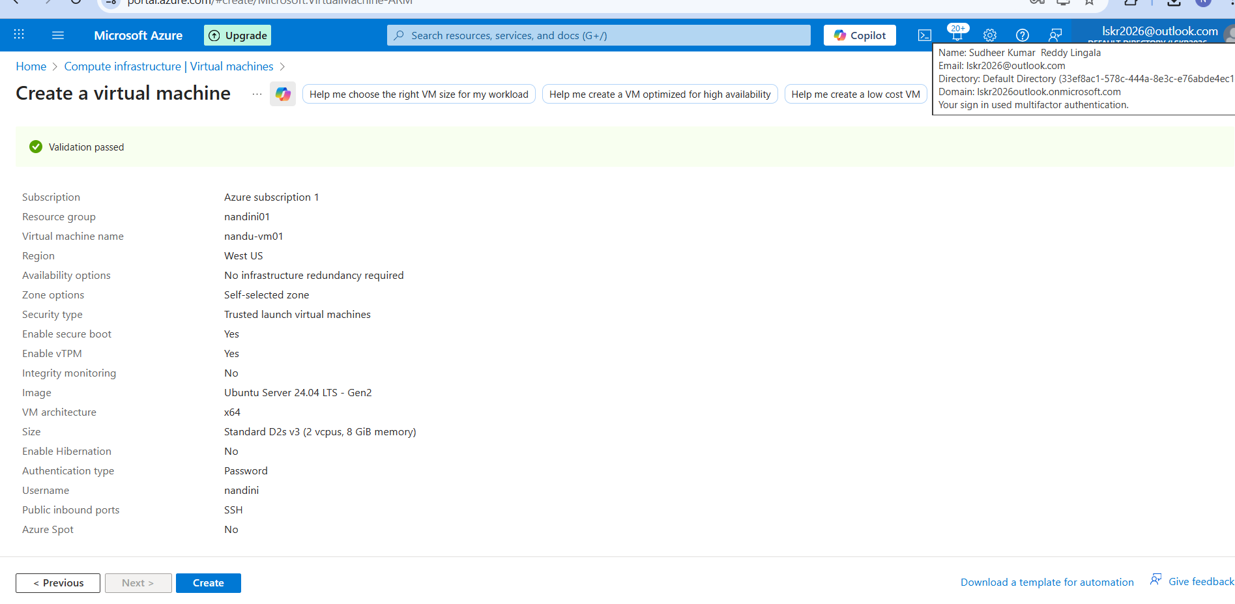
CONNECT THE MACHINE SSH
